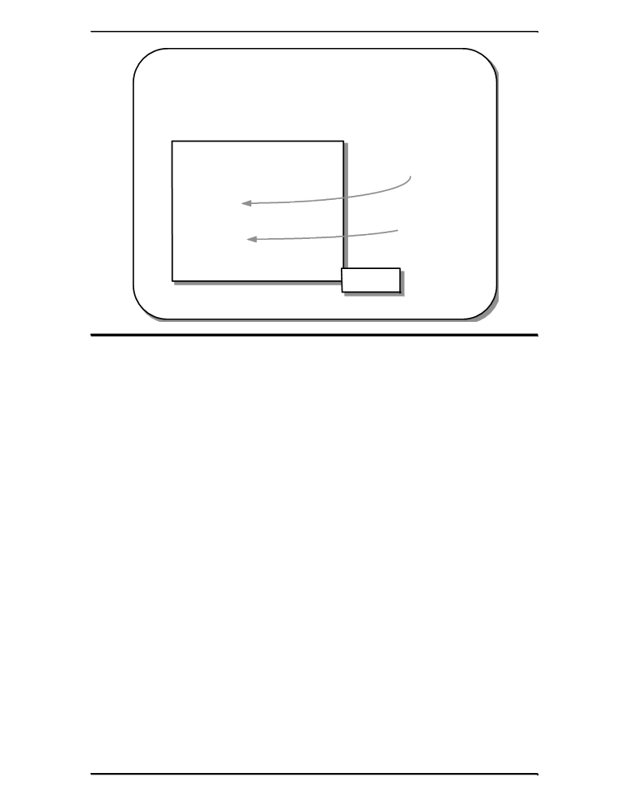

Prefix and Postfix

▪ The prefix and postfix versions are different

#include <stdio.h>

int main(void)
{
int i, j = 5;
i = ++j;
printf("i=%d, j=%d\n", i, j);
j = 5;
i = j++;
printf("i=%d, j=%d\n", i, j);
return 0;
} i=6, j=6
i=5, j=6

equivalent to:
1. j++;
2. i = j;

equivalent to:
1. i = j;
2. j++;

Sl

Prefix and Postfix

The two versions of the ++ and -- operators, the prefix and postfix versions, are different. Both will add one and subtract one regardless of how they are used, the
erence is in the assigned value.

Prefix ++, -- When the prefix operators are used, the increment or decrement happens first,
the changed value is then assigned. Thus with:

The current value of “j”, i.e. 5 is changed and becomes 6. The 6 is copied across
the “=” into the variable “i”.

Postfix ++, -- W h the postfix operators, the increment or decrement happens second. The
unchanged value is assigned, then the value changed. Thus with:
i = j++;

The current value of “j”, i.e. 5 is copied across the “=” into “i”. Then the value of
“j” is incremented becoming 6.

